SARA Naveed
Microarray project:
Submitted to: Dr Seher Aslam

Selecting disease:
- First, we reviewed several articles to select a disease of interest. After thorough reading and analysis, we narrowed our focus to COVID19
Downloading disease data:
- Go to genecard and search results of COVID19
- Then extract disease data into csv.
- And then remove duplicates genes from our data.
Selecting ligands:
- Next, I reviewed research papers to identify the ligands (A ligand is a molecule that binds specifically to a target, such as a protein, receptor, or enzyme, to form a complex and trigger a biological response.) responsible COVID19.
- Here is a list of ligands that narrow down from research papers
From them I shortlisted 12 ligands which smile structures present in pubchem.

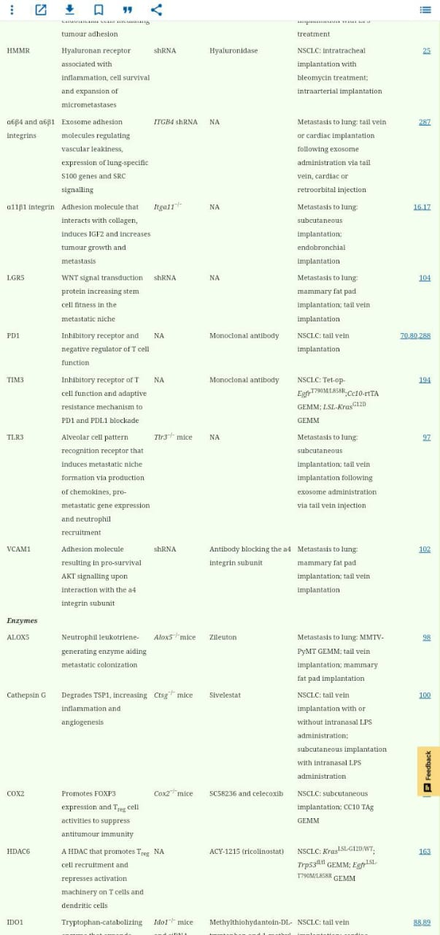
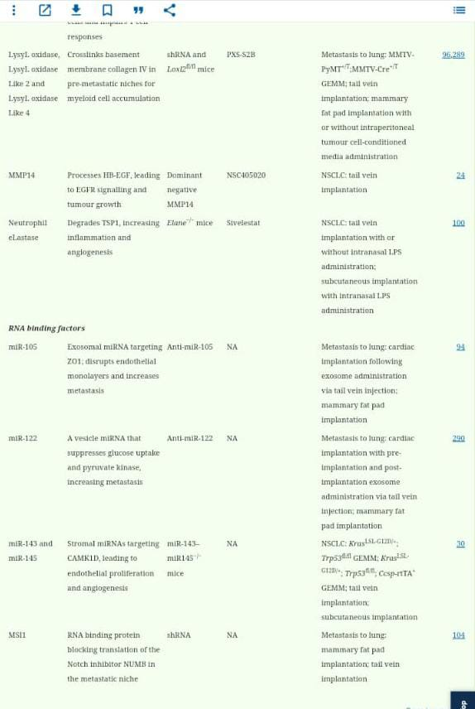
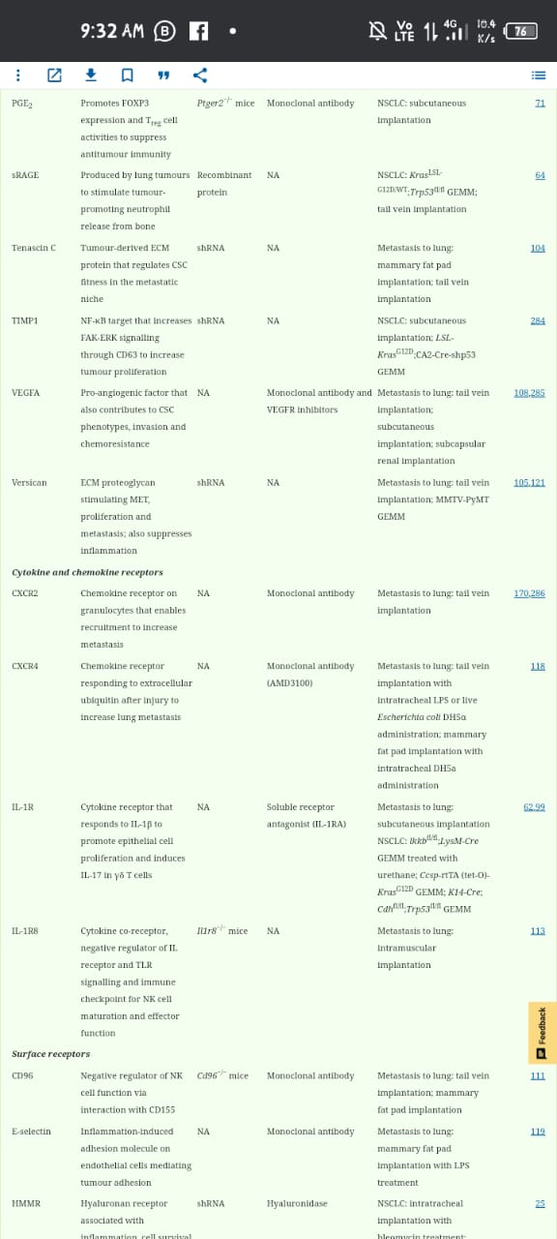
After shortlisting ligands next step is to find smile structure of hese ligands
Finding smile structures:
- Go to pumchem website then at its front page search every target by name.

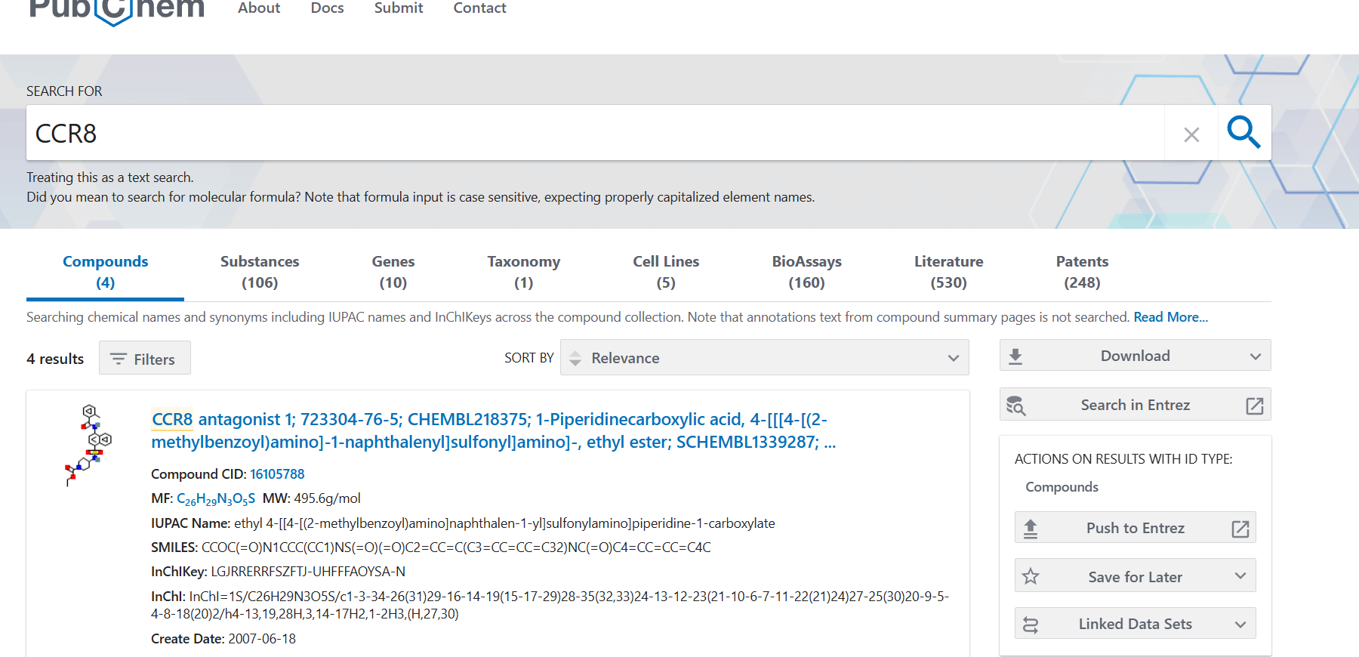

- After showing results click to molecule and scroll down to names and identifiers here we find out smile structures of our targets.

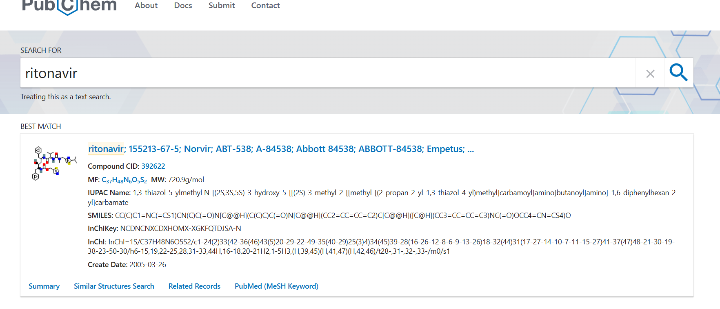
- And copy smiles of every target and save it into a word file to these smile structures.
Now I find out smile structures of 12 ligands that are following with ligand names:
gp120
SMILES: C[C@H]1[C@H]([C@H](C[C@@H](O1)O[C@H]2C[C@@](CC3=C2C(=C4C(=C3O)C(=O)C5=C(C4=O)C(=CC=C5)OC)O)(C(=O)CO)O)N)O
CXCR4
SMILES: C1CNCCNCCCN(CCNC1)CC2=CC=C(C=C2)CN3CCCNCCNCCCNCC3
Nevirapine
SMILES: CC1=C2C(=NC=C1)N(C3=C(C=CC=N3)C(=O)N2)C4CC4
Ritonavir
SMILES: CC(C)C1=NC(=CS1)CN(C)C(=O)N[C@@H](C(C)C)C(=O)N[C@@H](CC2=CC=CC=C2)C[C@@H]([C@H](CC3=CC=CC=C3)NC(=O)OCC4=CN=CS4)O
Lopinavir
SMILES: CC1=C(C(=CC=C1)C)OCC(=O)N[C@@H](CC2=CC=CC=C2)[C@H](C[C@H](CC3=CC=CC=C3)NC(=O)[C@H](C(C)C)N4CCCNC4=O)O
Atazanavir
SMILES: CC(C)(C)[C@@H](C(=O)N[C@@H](CC1=CC=CC=C1)[C@H](CN(CC2=CC=C(C=C2)C3=CC=CC=N3)NC(=O)[C@H](C(C)(C)C)NC(=O)OC)O)NC(=O)OC

Glycosphingolipids
SMILES: CCCCCCCCCCCCCCC[C@H]([C@H](CO[C@@H]1[C@@H]([C@H]([C@H]([C@H](O1)CO)O)O)O)NC(=O)CCCCCCCCCCCCC)O

CCR3
SMILES: CC1=C(SC(=N1)NC(=O)N[C@@H]2CCCC[C@H]2CN3CCC[C@H](C3)CC4=CC=C(C=C4)F)C(=O)C

CCR8
SMILES: CCOC(=O)N1CCC(CC1)NS(=O)(=O)C2=CC=C(C3=CC=CC=C32)NC(=O)C4=CC=CC=C4C

CCR1
SMILES: COC1=C(C=CC(=C1)N2CCN(CC2)C(=O)CN3C4=C(C=CC=N4)C(=N3)C5=NC=CN5)Cl

Swiss adme properties:
- after finding out smile structures of all ligends go to swissadme online tool via this link(http://www.swissadme.ch/index.php)
here we paste all smile structures that we copied into a word file
- After putting smile structure run them and when running complete all molecules results displayed below here then click on save as csv then swiss adme properties save a excel file in our system.
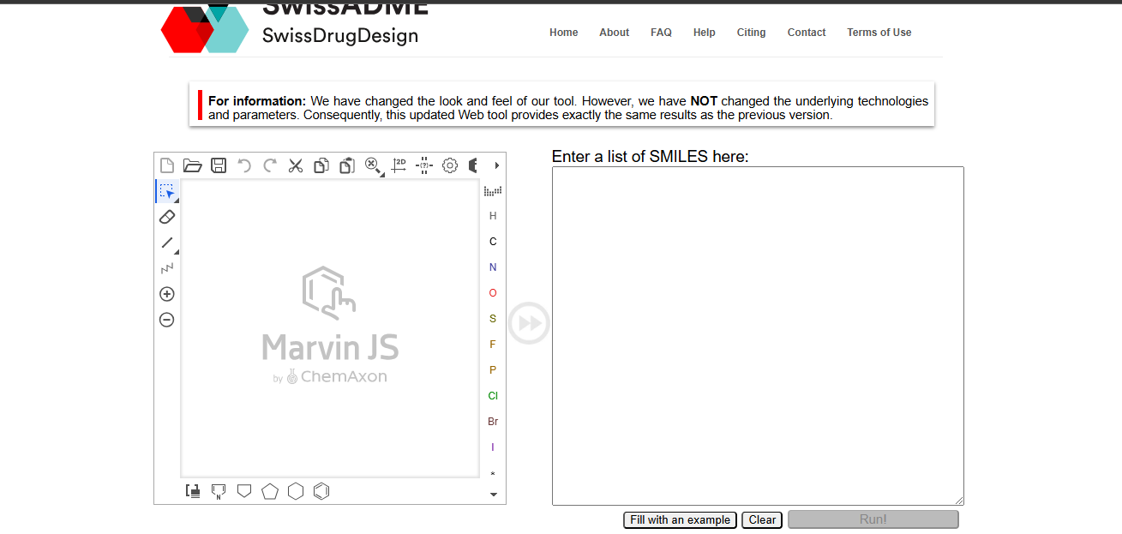

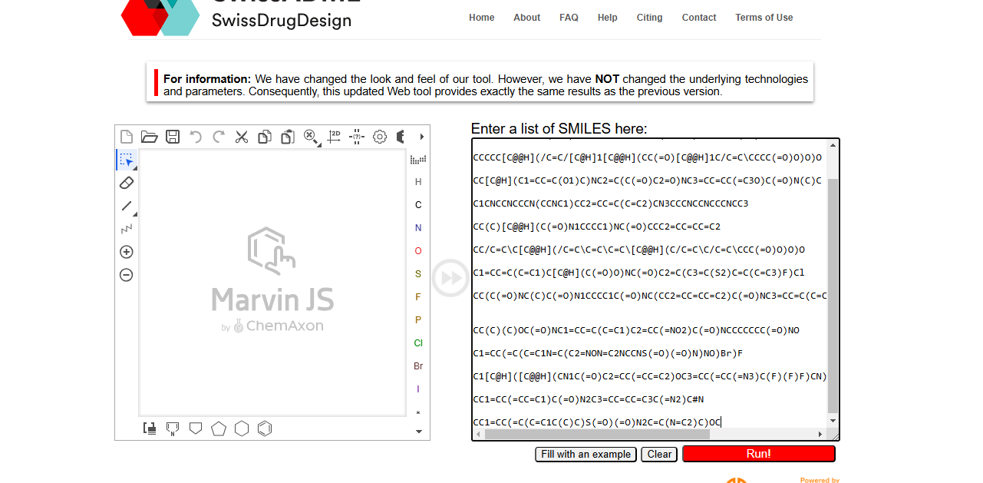
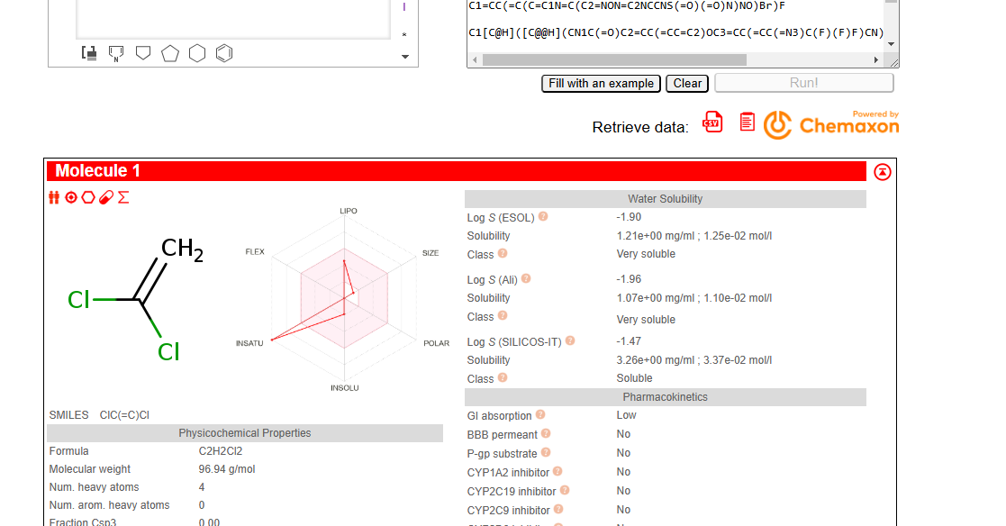
Swiss target prediction:
- After this step go to swiss target prediction tool(http://www.swisstargetprediction.ch/) to find out targets related to ligands.
- Then in this box put smile structure one by one and run them one by one and make csv file separate of every molecule .
- After downloading it paste these csv in one file and make one csv file.

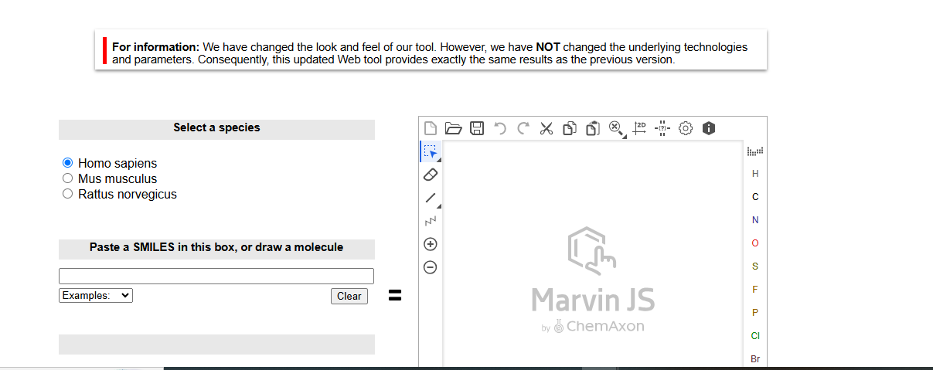

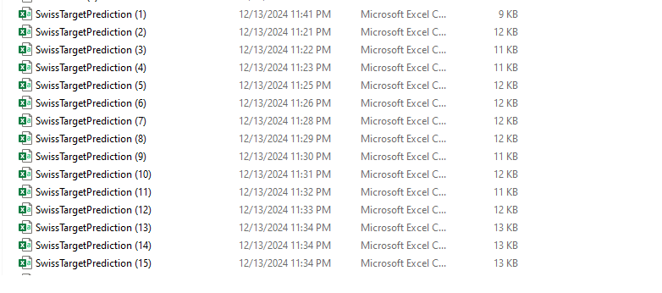
- After making csv of every molecule separately we paste it in a separate one csv.
Genevenn diagram:
- By venn diagram we find out common genes there is a venn diagram that shows 519 common genes.
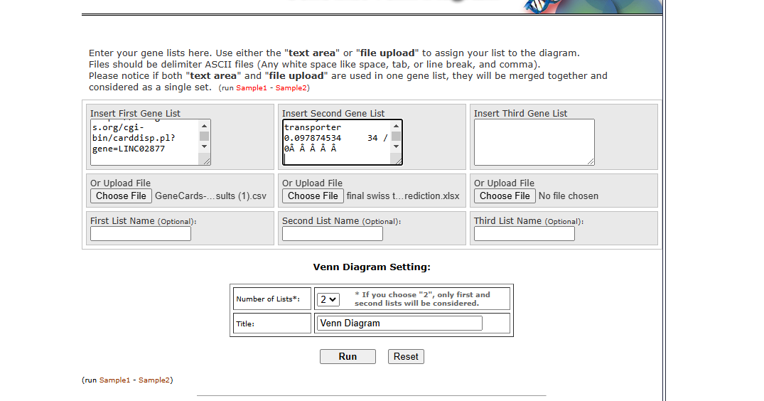
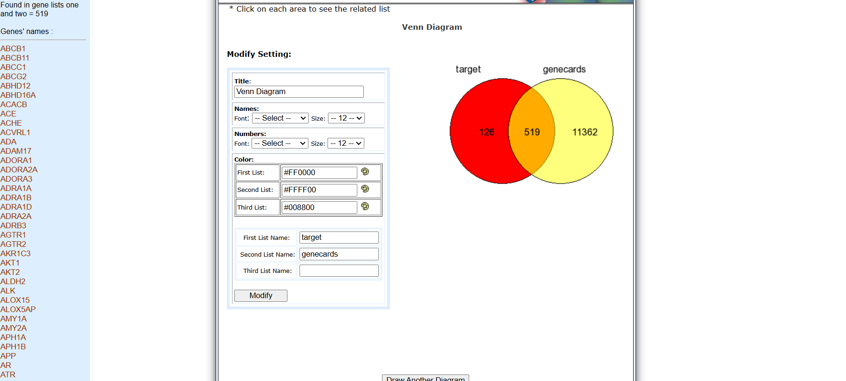
Then this list of genes are saved in a separate csv.
DAVID Database:
- Then in David database I input common gene list as input and run then a convert into tools and save table into csv file which contain biological process colum,kegg pathway,and gene antology then these columns are saved into separate separate excel sheets.
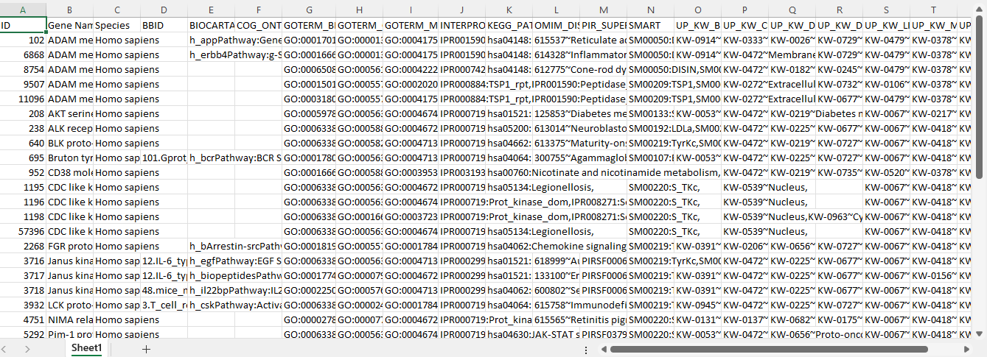
Then save these into separate sheets.
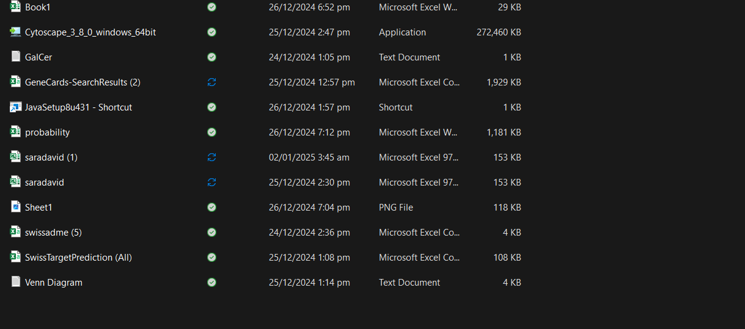

Ready file for run into cytoscape:
- Open excel sheet and firstly paste name of targets that we obtain from swiss target prediction in one column and in second column save name of molecules that responsible for targets. Then save them into csv.
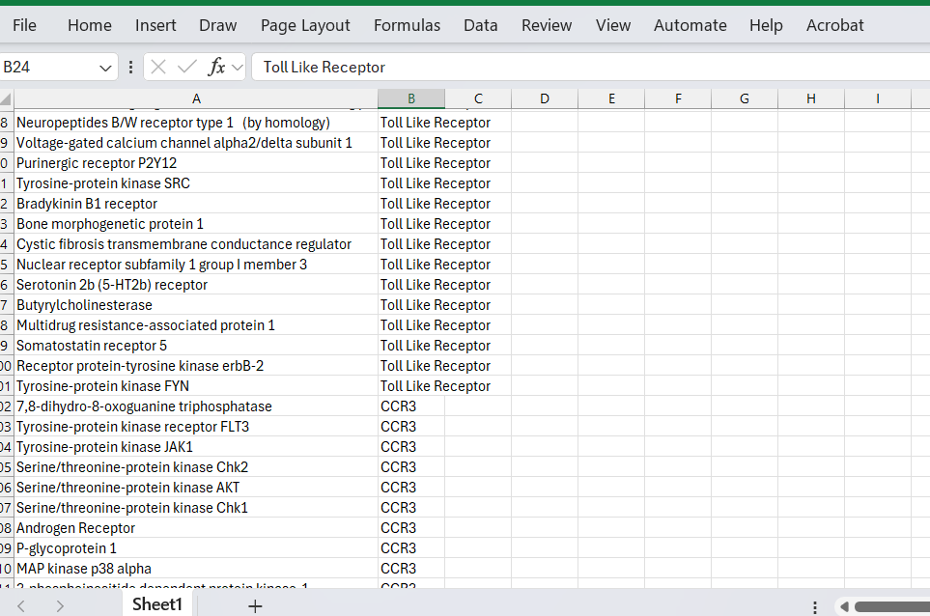
Now file ready for run into cytoscape.
Cytoscape:
- Install cytoscape and also java in our system and put them into same folder then open cytoscape.
- In cytoscpe go to file import network from file
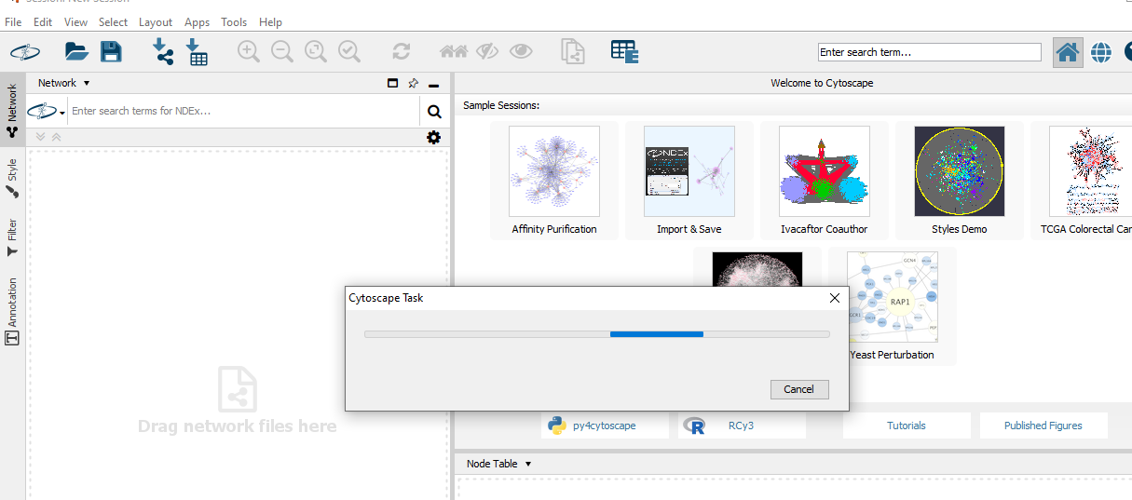
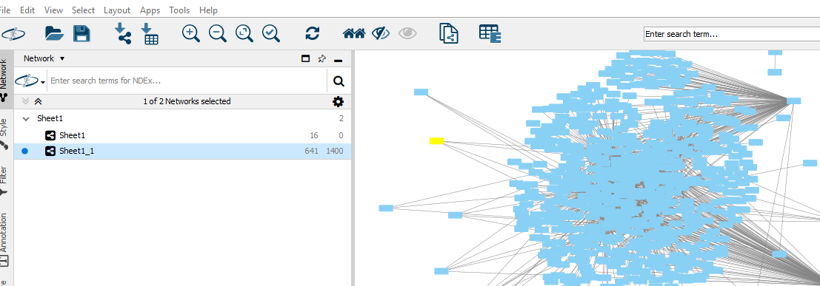

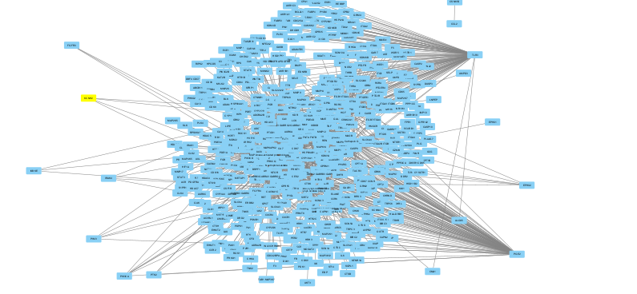
After go to string database:
- In string database we give them a list of common genes and select organism homosapiens then click on ok then on next page click on continue and a network of protein intraction draw
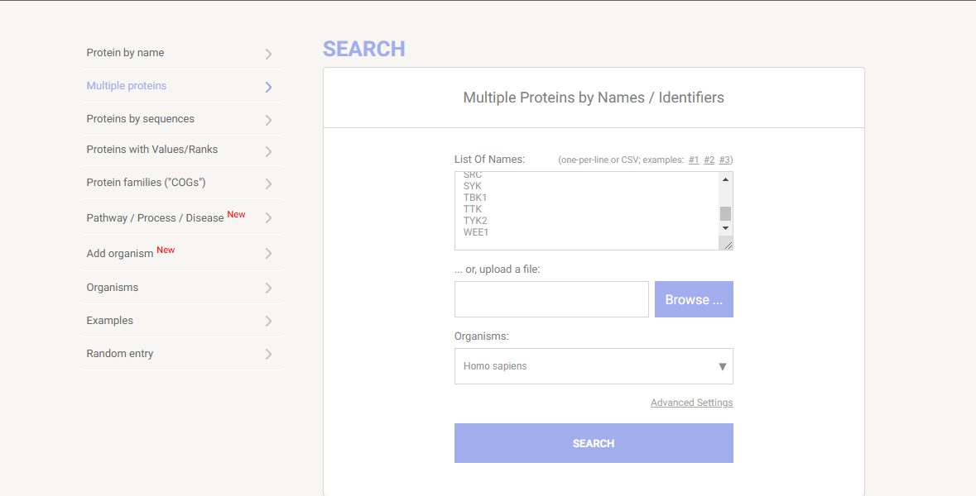

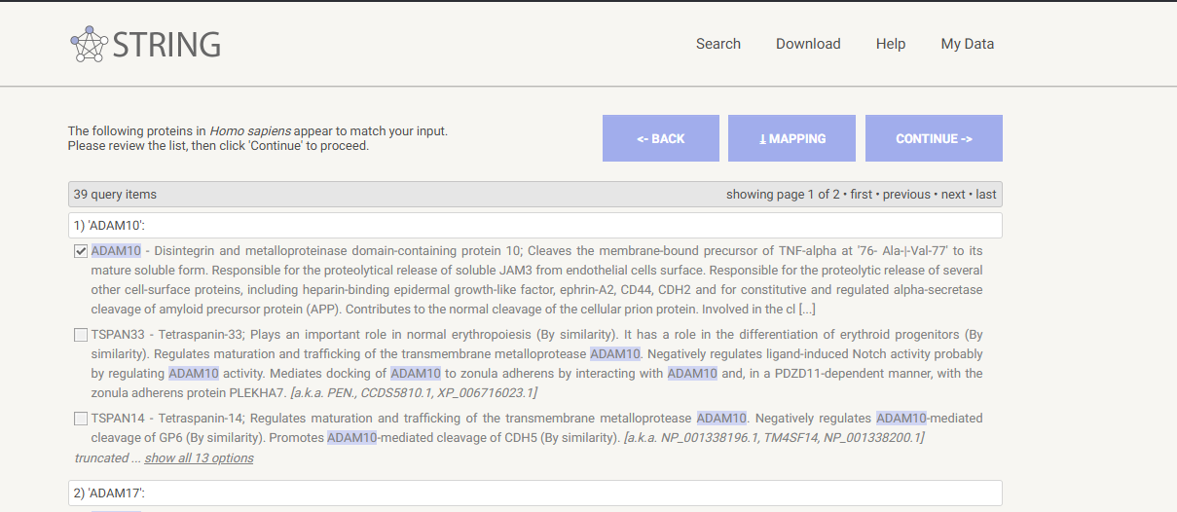

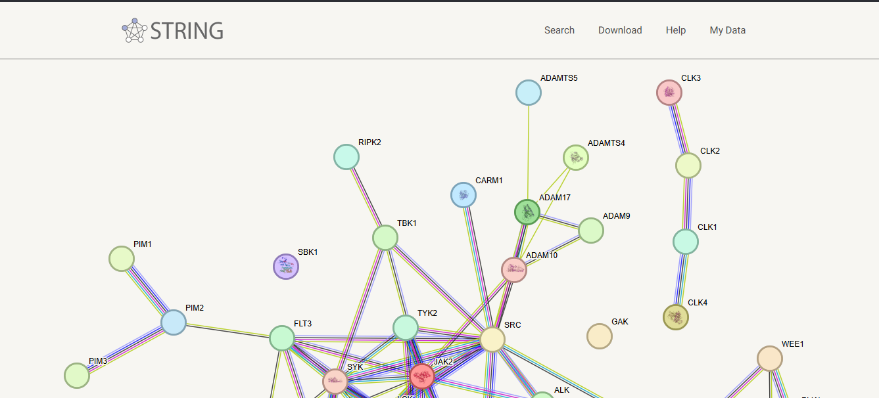
When we scroll down then go to export option and output text table and download on csv and then on table apply probability.
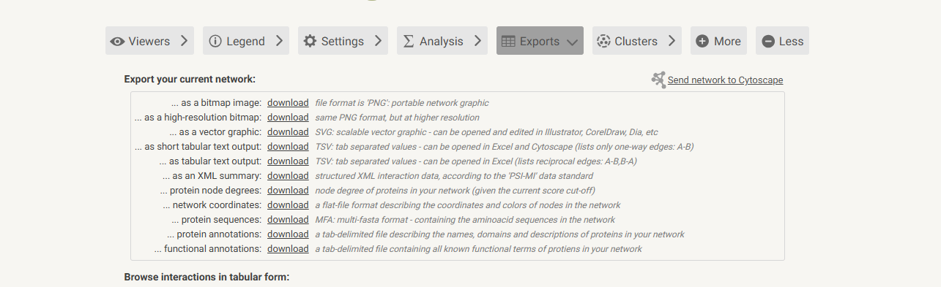
Apply probability:
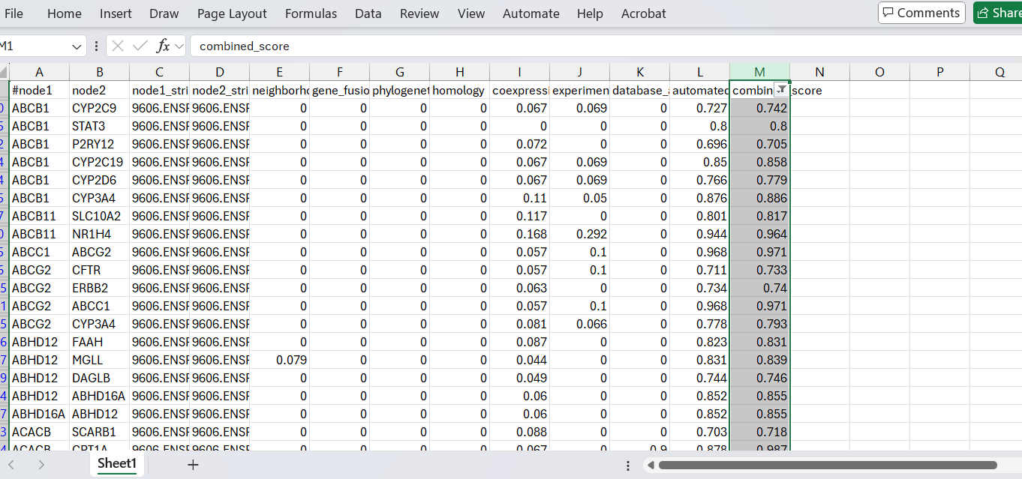

After that save this table as it is and go to cytoscape as import ,network from file, select source nodes ,edges,and click on ok.
Then go to cytohuba and click on calculate,click top 10,and check last three options and click on ok then hub genes network findout .

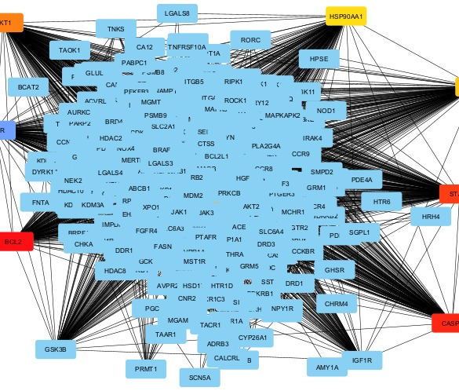
Then sava as png in your folder.

